

Autonomous college affiliated to VTU, Accredited by NBA and NAAC with “A” grade

**AUTOMATIC IRRIGATION SYSTEM**

**A MINI PROJECT**

**REPORT**

**SUBMITTED BY:**

CHITRA.S-1NH18EE010

E.KAVIPRIYA-1NH18EE013

GREESHMA CHENNAREDDY-1NH18EE017

***In partial fulfilment for the award of the degree of***

**BACHELOR OF ENGINEERING**

**IN**

**ELECTRICAL AND ELECTRONICS ENGINEERING**



Autonomous college affiliated to VTU, Accredited by NBA and NAAC with “A” grade

**BONAFIDE CERTIFICATE**

This is to bonafide that the mini project report entitled “AUTOMATIC IRRIGATION SYSTEM” submitted by CHITRA.S(1NH18EE010),E.KAVIPRIYA(1NH18EE013) and GREESHMA CHENNAREDDY(1NH18EE017) Department of Electrical Engineering, New Horizon College of Engineering, Bangalore in partial fulfilment for the award of the degree of bachelor of engineering, is a record of bonafide work carried out by him/her under my supervision, as per the NHCE code of academic and research ethics.

The contents of this report have not been submitted and will not be submitted either in part or in full, for the award of any other degree or diploma in this institute or any other institute or university. The project report fulfils the requirements and regulations of the institution and in my opinion meets the necessary standards for submission.

Mr. Vinod Kumar.S Dr. S. Ramkumar

Project Guide HoD



Autonomous college affiliated to VTU, Accredited by NBA and NAAC with “A” grade

**ACKNOWLEDGEMENT**

With immense pleasure and deep sense of gratitude, We wish to express our sincere thanks to our supervisor Mr. Vinod Kumar. S, Senior Assistant professor, Department of Electrical Engineering, New Horizon College of Engineering, without his motivation and continuous encouragement, this mini project would not have been successfully completed.

We are grateful to the chairman of New Horizon Educational institution, Dr. Mohan Manghnani for motivating us to carry out research in NHCE and for providing us with infrastructural facilities and many other resources needed for our project work.

We express my sincere thanks to Dr. S Ramkumar, HOD, Department of Electrical Engineering, New Horizon College of Engineering for his kind words of support and encouragement.

We wish to extend our profound sense of gratitude to our parents for all the sacrifices they made during our project and providing us with moral support and encouragement whenever required.

Date:

Place:Bangalore

Chitra. S

E. Kavipriya

Greeshma Chennareddy

**TABLE OF CONTENTS**

1. **ABSTRACT**
2. **INTRODUCTION**
3. **CIRCUIT DIAGRAM**
4. **HARDWARE REQUIREMENTS**
5. **CIRCUIT DIAGRAM AND WORKING**
6. **RESULTS**
7. **CONCLUSION**
8. **BIBLIOGRAPHY**
9. **APPENDICES**

**ABSTRACT**

Agriculture is the source of living of majority Indians and it also has a countless influence on the economy of our country.

The objective of our project is to reduce manual involvement by the farmer by using a smart irrigation system whose purpose is to enhance water use for agricultural crops. This report deals with automatic irrigation system which senses the moisture content of the soil and automatically switches the pump when the power is ON. An automation of farm irrigation is proposed by soil moisture control by using 555Timer.

The motivation for this project came from the countries where economy is based on agriculture and climatic conditions lead to lack of rains and scarcity of water. The farmers working in the farm lands are solely dependent on the rains and bore wells for irrigation of the land. Even if the farm land has water-pump, manual intervention is required to turn the pump ON/OFF whenever needed. Our project aims at minimising the manual intervention by the farmer.

Automatic irrigation system will serve the following purposes:

1.As there is no unplanned usage of water, a lot of water is saved from being wasted.

2. The irrigation is only when there is not enough moisture in the soil and the sensors decides when the pump has to be turned ON/OFF, this saves a lot of time for the farmers.

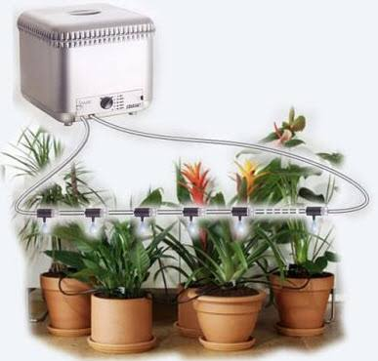

Fig.1. Automatic irrigation system

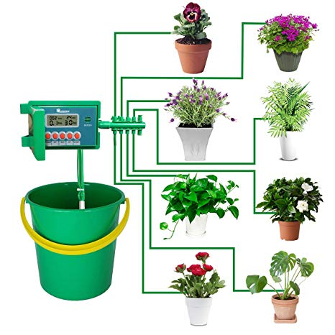

Fig.2.Automatic irrigation system

Irrigation is the key to a successful garden. Long gone are the days of manual watering or relying on a friend to water when you are on a vacation or away on a business. Our project helps in watering plants regularly without human interference. The circuit comprises sensor parts such as soil moisture sensor modules used here have two output pins(Digital output and Analog output). The output from the probe of the moisture sensor is compared with a reference value. The reference value can be changed by turning on the potentiometer in the module. The digital pin gives an active low output when the soil is wet. According to the output of the sensor the motor is turned ON/OFF. This project works with 5V regulated power supply. Power on LED(Light Emitting Diode) is connected for visual identification of power status.

**INTRODUCTION**

The increasing demand of the food supplies requires a rapid improvement in food production technology. In many countries where agriculture plays an important part in shaping up the economy and the climatic conditions are isotropic, but still we are not able to make full use of agricultural resources. Extraction of water at regular intervals from the earth is reducing the water level as a result of which zones of un-irrigated land are gradually increasing. Also, the unplanned use of water inadvertently results in wastage of water.

As we know Indian economy is one of the largest developing economies in the world. The agricultural sector has its largest contribution in the Indian economy. To achieve maximum utilisation of man power and to obtain maximum profit there is a need in the up gradation of various engineering techniques that are being used today. Thus maintaining proper amount of water level in the soil is one of the necessary requirements to harvest a good crop that can be a source of various types of nutrients whether macro or micro for their proper growth. If we talk about Indian farmers they are worst hit by the famines that occurs due to failure of crops depending on the various drought factors.

In Smart Irrigation system, the most significant advantage is that water is supplied only when the moisture in the soil goes below a pre-set threshold value. This saves a lot of water. In recent times, the farmers have been using irrigation technique through the manual control in which the farmers irrigate the land at regular intervals by turning the water pump ON/OFF whenever required. This process sometimes consumes a lot of water and the water supply to the land is delayed at times due to which the crops dry-out. Water deficiency deteriorates plant growth before visible wilting occurs. In addition to this slow growth rate, lighter weight fruit follows water deficiency. This problem can be perfectly rectified if we use Automated Irrigation system in which the irrigation will take place only when there will be intense requirement of water, as suggested by the moisture in the soil.

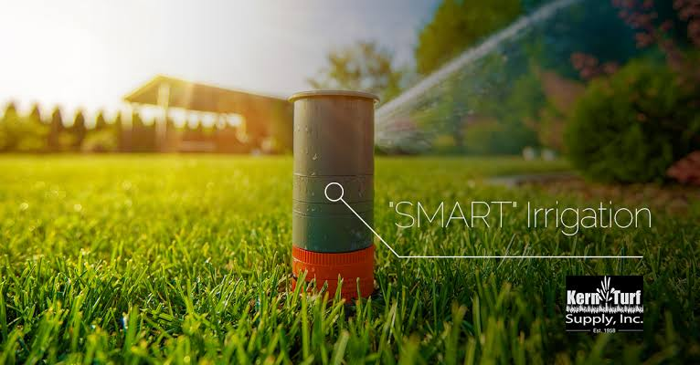

Fig.3.Automatric irrigation system

**BLOCK DIAGRAM**

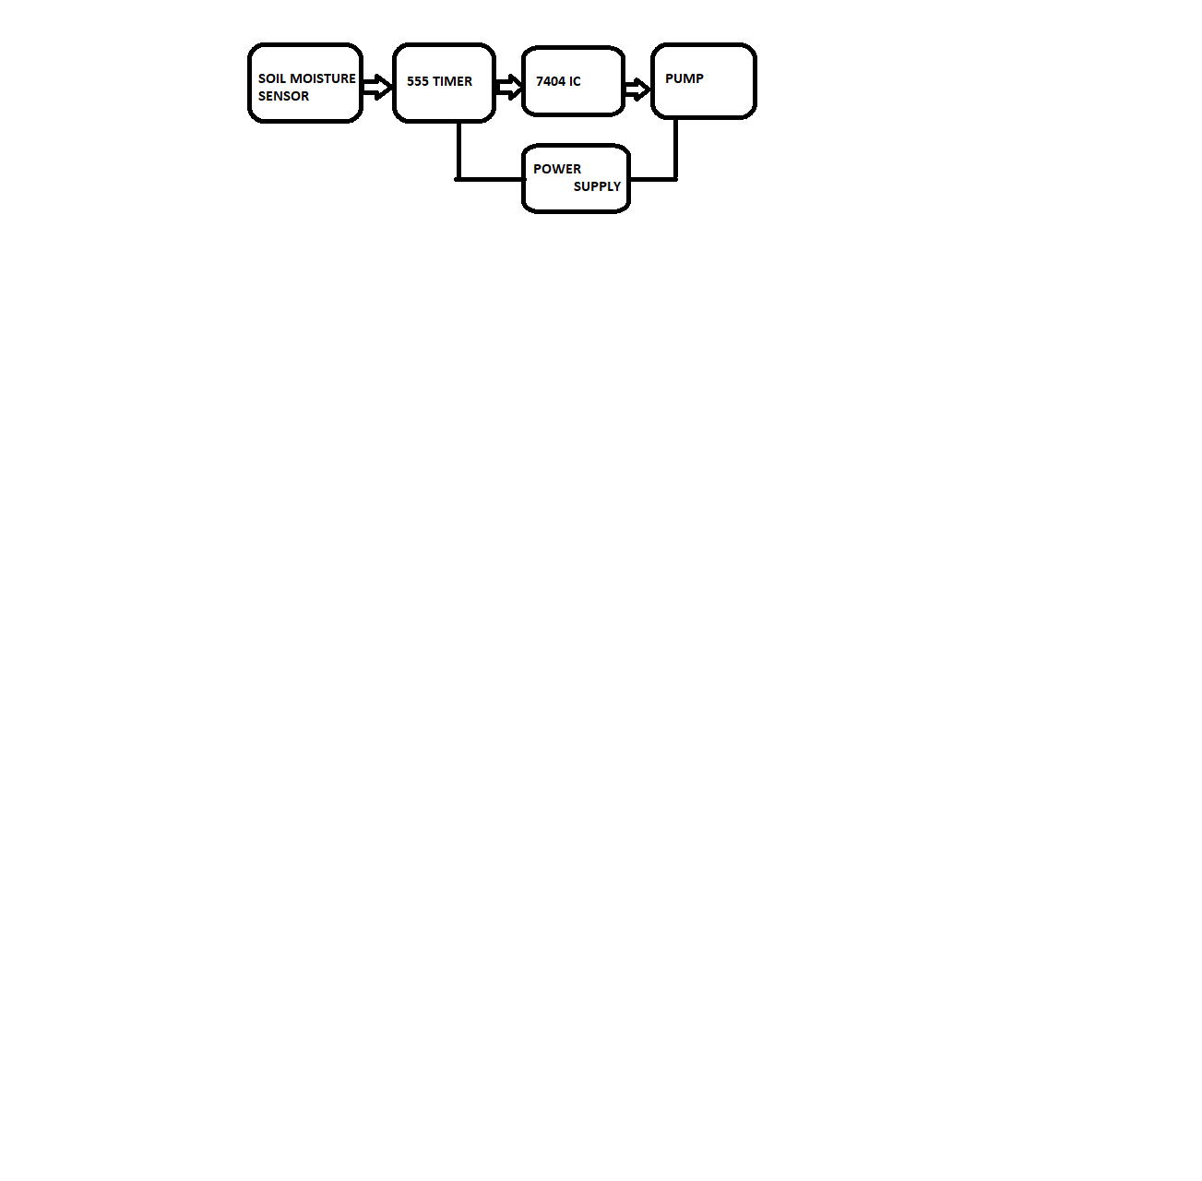

When the power supply is on and if the soil is in dry condition the soil moisture sensor sends a signal to the 555 timer and then the output of the 555timer is sent to the 7404 IC. The 7404 IC gives an output (1 for dry condition) and this output is given to the pump. Since the soil is dry the and the output from the 7404 IC is one the pump is switched on. Once the soil becomes wet the soil moisture sensor sends another signal to the 555 timer and the output of the 555 timer is sent to the 7404 IC. The 7404 IC gives an output (0 for wet condition) and this output is given to the pump. Therefore, the pump is switched off.

**CIRCUIT DIAGRAM**

D s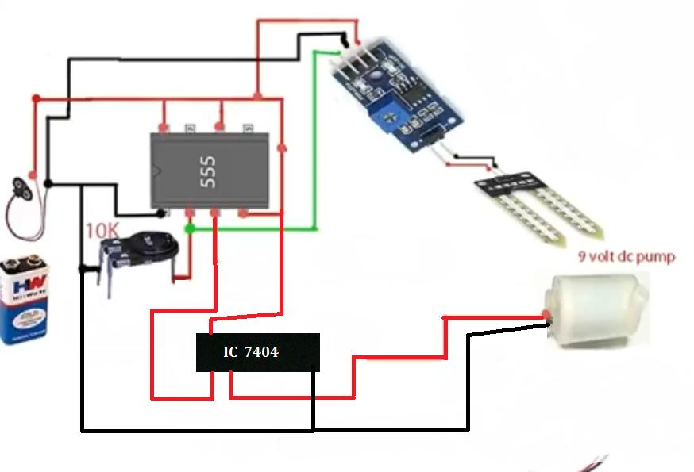

Fig.4. Circuit diagram of Automatic irrigation System

**LIST OF COMPONENTS**

|  |  |  |
| --- | --- | --- |
| SL.NO | COMPONENTS | VALUE |
| 1. | 555 TIMER | NE555 |
| 2. | POTENTIOMETER | 100K |
| 3. | SOIL SENSOR |  |
| 4. | DC WATER PUMP | 9V |
| 5. | 7404 IC |  |
| 6. | BATTERY | 9V(2BATTERIES) |
| 7. | LED (LIGHT EMITTING DIODE) | RED |
| 8. | RESISTOR | 1K |

**LIST OF FIGURES**

* Fig.1. Automatic Irrigation System
* Fig.2. Automatic Irrigation System
* Fig.3. Automatic Irrigation System
* Fig.4. Circuit Diagram of Automatic Irrigation System
* Fig.5. Resistors
* Fig.6. Colour code of resistors
* Fig.7. Soil moisture sensor
* Fig.8.1. Working of 555 IC Timer
* Fig.9. Pin diagram of 555 IC Timer
* Fig.10. Potentiometer
* Fig.11.1. Light emitting diodes (LEDs)
* Fig.11.2. Parts of LED
* Fig.12. 9V DC battery
* Fig.13. DC water pump

**HARDWARE REQUIREMENTS**

The circuit diagram of Smart Irrigation System is built around one of the most popular IC, IC555. It also includes pump and the other passive components 555 IC: The 555 IC is an integrated circuit chip used in a variety of timer, pulse generation, and oscillator applications. The 555 can be used to provide time delays, as an oscillator and as a flip-flop element.

**SPECIFICATION OF COMPONENTS:**

**RESISTOR:**

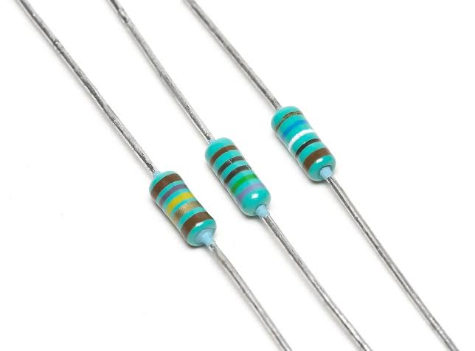

Fig.5. Resistors

A resistor offers a resistance to the flow of current and act as voltage droppers or voltage dividers. They are “Passive Devices”, that is they contain no source of power or amplification but only attenuates or reduces the voltage signal passing through them. For high current operations resistance of higher current ratings are used. Resistance is the opposition that a substance offers to the flow of electric current. It is represented by ‘R’. The standard unit of resistance is ohm. When an electric current of one ampere passes through a component across which a potential difference(voltage) of one volt exists, then the resistance of that component is one ohm.

In general, When the applied voltage is held constant, the current in a direct-current (DC) electrical circuit is inversely proportional to the resistance. If the resistance is doubled, the current is cut in half; If the resistance is halved, the current is doubled. This rule also holds true for most low-frequency alternating AC systems, such as household utility circuits. In some AC circuits, especially at high frequencies, the situation is more complex, because some components in these systems can store and release energy, as well as dissipating and converting it.

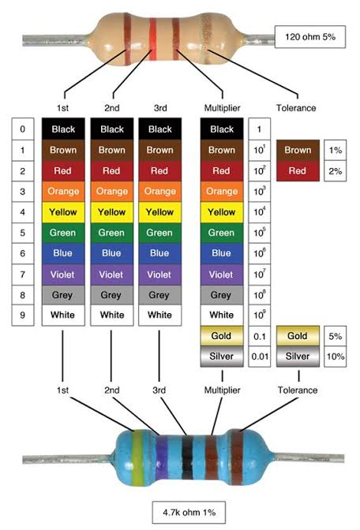

Fig. 6. Colour code of resistors

**SOIL MOISTURE SENSOR:**

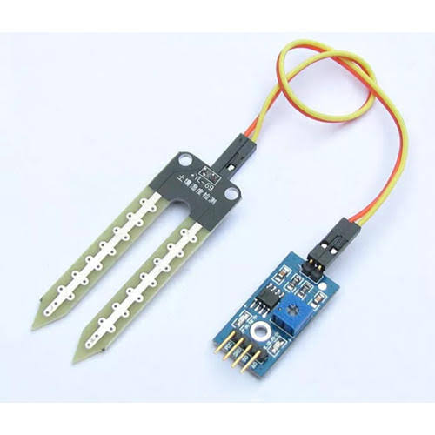

Fig. 7. Soil moisture sensor

The soil moisture sensor measures the humidity of water content in the soil. The soil moisture sensor consists of two probes which are used to measure the volumetric content of water. The two probes allow the current to pass through the soil and then it gets the resistance value to measure the moisture value. When there is more water, the soil will conduct more electricity which means there will be less resistance. Therefore, the moisture level will be higher. Dry soil conducts electricity poorly, so when there will be less water, the soil will conduct less electricity which means that there will be more resistance. Therefore, the moisture level will be lower. This sensor can be sued in analog as well as digital mode. First, we will conduct in Analog mode and then we will use it in digital mode.

**555 TIMER:**

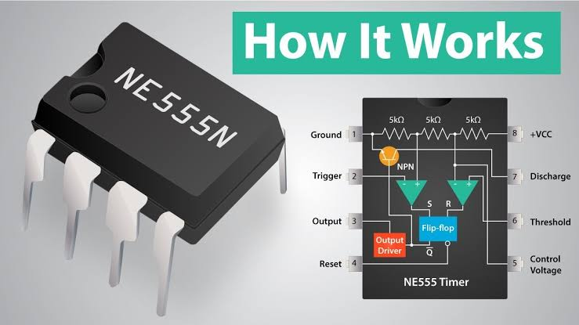

Fig.8.1. Working of 555 IC Timer

In monostable mode the 555 timer outputs a high pulse, which begins when the trigger pin is set low (less than 1/3 Vcc, as explained in the previous step, this is enough to switch the output of the comparator connected to the trigger pin). The duration of this pulse is dependent on the values of the resistor R and capacitor C in the image above. When the trigger pin is high, it causes the discharge pin (pin 7) to drain all charge off the capacitor (C in the image above). This makes the voltage across the capacitor (and the voltage of pin 6) = 0. When the trigger pin gets flipped low, the discharge pin is no longer able to drain current; this causes charge to build up on the capacitor according to the equation below. Once the voltage across the capacitor (the voltage of pin 6) equals 2/3 of the supply voltage (again, as explained in the previous step, this is enough to switch the output of the comparator connected to pin 6), the output of the 555 is driven back low.

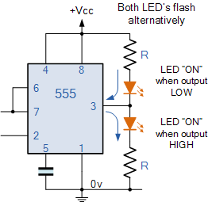

Fig.9. Pin diagram of 555 IC Timer

**POTENTIOMETER**

A potentiometer informally a pot is a three-terminal resistor with a sliding contact that forms an adjustable voltage divider. If only two terminals are used, one end and the wiper, it acts as a variable resistor or rheostat. A potentiometer measuring instrument is essentially a voltage divider used for measuring electric (voltage); the component is an implementation of the same principle, hence its name. Potentiometers are commonly used to control electrical devices such as volume controls on audio equipment. Potentiometers operated by a mechanism can be used as potential transducers, for example, in a joystick. Potentiometers are rarely used to directly control significant power (more than a watt), since the power dissipated in the potentiometer would be comparable to the power in the controlled load. As shown in the diagram a variable resistor consists of track which provides the resistance path. Two terminals of the device are connected to both the ends of the track. The motion of the wiper through the track helps in increasing and decreasing the resistance.

The track is usually made of a mixture of ceramic and metal or can be made of carbon as well. As a resistive material is needed, carbon film type variable resistors are mostly used. They find applications in radio receiver circuits, audio amplifier circuits and TV receivers. For applications of small resistances, the resistance track may just be coil of wire. The track can be in both the rotary as well as straight versions. In a rotary track some of them may include a switch. The switch will have an operating shaft which can be easily moved inthe axial direction with one of its moving from the body of the variable resistor switch. The rotary track resistor has two applications. One is to charge the resistance. The switch mechanism is used for the electric contact and non-contact by on/off operation of the switch. There are switch mechanism variable resistors with annular cross-section which are used for the control of equipment. Even more components are added onto this type of a variable resistor so as to make them compatible foe complicated electronic circuits. A high voltage variable resistor such as a focus pack is an example. This device is capable of producing a variable focus voltage as well as a screen voltage. It is also connected to a variable resistance circuit and also a fixed resistance circuit (bleeder resistor) to bring a change in the applied voltage. For this both the fixed and the variable resistor are connected in series. A track made in a straight path is called a slider. As a position of a slider cannot be seen or confirmed according to the adjustment of resistance, a stopping mechanism is usually included to prevent the hazards caused due to over rotation.

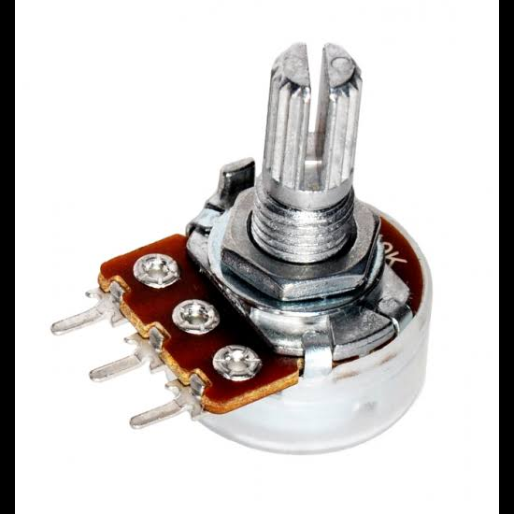

Fig.10. Potentiometer

**LED (Light Emitting Diode)**

The main specification of LED are its current rating = 20 mA, typical cut in voltage= 2 V, life time= 2 lakh hours, approx. voltage is around 4.5 V. There is different colour LED’s depending on the semi conducting material. LED has two leads – cathode and anode. They are identified by the length of the lead. Cathode lead is of lesser length. The maximum value of 470 ohm can be inserted for a small light.

LED is a semiconductor light source that emits light when current flows through it. When a current flow through the diode, electrons are able to recombine with electron holes within the device releasing energy in the form of photos. This effect is called electroluminescence. The colour of the light (corresponding to the energy of the photons) is determined by the energy band gap of the semiconductor. White light is obtained by using multiple semiconductors or a layer of light-emitting phosphor on the semiconductor device.

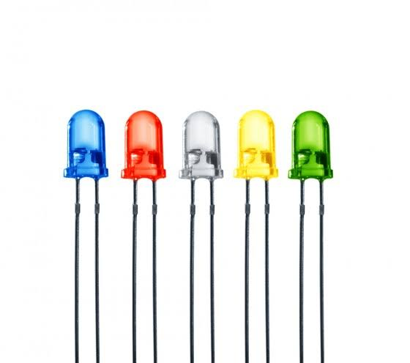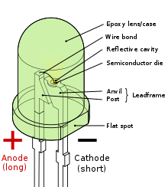

Fig.11.1. Light emitting diodes (LEDs) Fig.11.2. Parts of LED

**9 V POWER SUPPLY**

The most common form of nine – volt battery is commonly called the transistor battery, introduced for the early transistor radios. This is a rectangular prism shape with rounded edges and a polarized snap connector at the top. This type is commonly used in pocket radios, smoke detectors, carbon monoxide detectors, guitar effect units, electro-acoustic guitars and radio-controlled vehicle controllers. They are also used as backup power to keep the time in certain electronic clocks. This format is commonly available in primary carbon-zinc and alkaline chemistry, in primary lithium ions disulphide, and in rechargeable form in nickel-cadmium, nickel-metal hydride and lithium-ion. Mercury oxide batteries in this form have not been manufactured in many years due to their mercury content.

As of 2007, 9- volt batteries accounted for 4% of alkaline primary battery sales in the US. In Switzerland as od 2008, 9-V batteries totalled 2% of primary battery sales and 2% of secondary battery sales.

The TenergyCentura 9V battery is, of course, the same size and shape as any other 9V battery. Its rated capacity is 200 mAh, which is about half the capacity of a disposable 9V alkaline batteries, and slightly below average among the rechargeable 9 V NiMH batteries.

Like any NiMH(or NiCd) 9V battery, the TenergyCentura doesn’t actually produce 9 V. This is because NiMH and NiCd batteries must be made up from individual NiMH or NiCd cells each of which produces 1.2 V. Thus, the voltage of the entire battery must be a multiple of 1.2 V.

A disposable alkaline 9V battery is made up of six 1.5 V alkaline cells, giving a total of 9 V. Many “9V” rechargeable batteries are similarly made of from six 1.2 V NiMH cells, giving a total of only 7.2 V. Some devices designed to operate from 9V batteries will not work with such a low voltage.

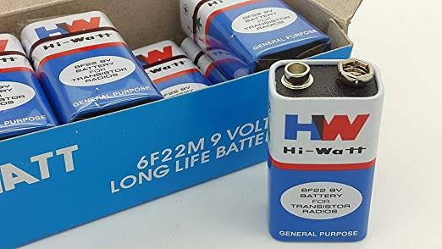

Fig. 12. 9V DC Battery

**DC WATER PUMP**

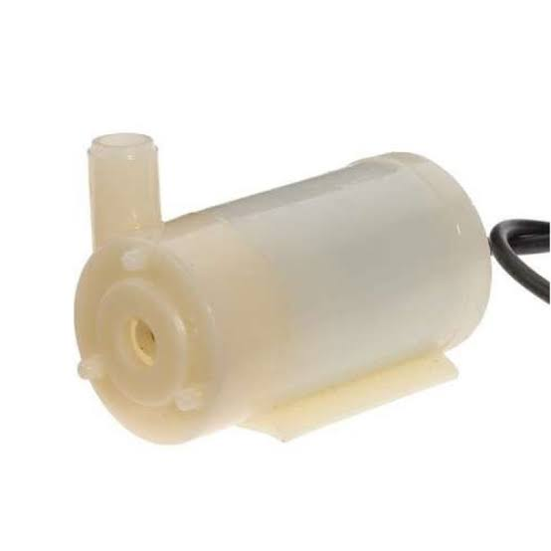

Fig.13. DC water pump

When the soil is dry the soil moisture sensor sends a signal to the IC555 timer and the signal from the timer turns ON the pump. And when the soil is wet the soil moisture sends a signal to turn OFF the pump.

**CIRCUIT WORKING**

* We are all well aware that the plants will die due to lack of water in the soil. Soil will have high resistance when it is dry and it will have very low resistance when soil is wet. We use this simple logic to water the plants and make the circuit work.
* Two probes which are connected to the circuit are placed into the soil. The two probes will conduct only when the soil is wet (resistance is low) and they cannot conduct when the soil is dry due to high resistance. The voltage is given to the probes to conduct is given from the battery connected to the circuit.
* When the soil is dry it will produce large voltage drop due to high resistance. This is sensed by 7404 hex invertor and makes the NE555 timer trigger which is configured as monostablemultivibrator with the help of an electrical signal.
* When the NE555 is triggered at pin 2, it will generate the output at pin 3 which is given to the input of second NE555 timer. The second 555 timer is configured as stable multivibrator which got triggered by the first 555 timer and will generate the output.
* The output of second NE555 timer will switch on the pump.
* When the water content in the soil is increased, the resistance in the soil will get decreased and conduction of the probes will get started which will make the 7404 Inverter to stop the triggering of first 555 timer. Ultimately it will stop the electrical timer which is connected to the relay. Variable resistor(R5) and capacitor (C1) are used to adjust the valve when we want to conduct the probes.
* The capacitor C5(0.01uf) is used to ground, the CV pin of second NE555 timer. C3 will remove the AC noise and allow only DC to the remaining circuit. C4 and R3 will constitute to configure the NE555 in a stable multivibrator.

**RESULTS**

The system when tested in the field conditions revealed that it would be a best option for medium size agricultural field. Operational amplifier reference voltage could be changed according to the crop type and moisture availability in the field by using moisture sensor. Excess power was stored in the solar battery and it was used when day light was low. Excess charging was prohibited by using pulse width modulation technique and it helped to reduce the temperature of the solar battery and increase the life time of the battery. When all probes were dry, water pump was switched on until all the probes were getting wet. As well when all probes were wet, it allocated to dry till the probes and utilise the water and power sustainable manner. If further reduction of the moisture of the soil occurred, it leaded to switch on the pump till all probes get wet. Because of this automated system, water wastage of tested fields could be reduced to 50% of normal irrigation wastage and reduce evaporation transpiration by induced dark time operation. Beside human attention was reduced on irrigation due to automation. Irrigation becomes easy, accurate and practical with the impression above shared and can be executed in agricultural fields in future to endorse agriculture to the next level. The output from moisture sensor and level system plays a wide role in producing the output.

**ADVANTAGES**

* Highly sensitive
* Works according to the soil condition
* Fit and Forget system
* Low cost and reliable circuit
* Complete elimination of manpower
* Can handle loads up to 7A
* System can be switched into manual mode whenever required

**APPLICATIONS**

* Roof gardens
* Lawns
* Agricultural lands
* Home gardens

**CONCLUSION**

The circuit is more effective indoors if one intends to use it for long periods. This is because the water from the reservoir (bucket, etc.,) evaporates rapidly if it is kept in the open. For regulating the flow of water, either a tap can be used or one of a rubber pipes can be blocked using M-seal compound, with holes punctured along its length to water several plants.

The aim of this implementation was to demonstrate that the automatic irrigation system can be used to optimise/reduce water usage. It can also be a photovoltaic irrigation system which consists of a solar powered that is the soil moisture sensor and temperature sensor placed under the soil where plant roots are reached which is a distributed network. The system can have a water level sensor which will indicate the presence of water level in tank. A software application which is advanced by programming the verge values of soil moisture water level that can be automated into a microcontroller can be used. This project can be upgraded using Arduino also.

Smart Irrigation system is a step to utilise some new engineering techniques. This technique will be a very good option for the small and medium farmers who suffer every year just because of failure of crops that take place nearly every year. The implementation of this technology has a wide scope in the nearby future.

**APPENDICES**

|  |  |
| --- | --- |
| **ABSTRACT** | PAGE 5 |
| **ACKNOWLEDGEMENT** | PAGE 3 |
| **BIBLIOGRAPHY** | PAGE 24 |
| **BLOCK DIAGRAM** | PAGE 8 |
| **CIRCUIT DIAGRAM** | PAGE9 |
| **CIRCUIT WORKING** | PAGE 19 |
| **CONCLUSION** | PAGE 22 |
| **HARDWARE REQUIREMENTS** | PAGE 12 |
| **INTRODUCTION** | PAGE 7 |
| **RESULTS** | PAGE20 |

**BIBLIOGRAPHY**

* http://www.electronics-manufacturers.com
* <http://www.datasheetcatalog.org>
* <http://www.circuit>sarena.com/2014/08/automatic-plant-irrigation-system-using.html
* www.kpsec.freeuk.com
* Principles of electronics by V.K. Mehta
* Linear Integrated Circuits
* Basic electronics by Boyleste D